# CS 340 README

### About the Project/Project Title

*The application will allow a user to access a database of animals. This will allow the user to create, read, update, and delete (CRUD) animals from this database.*

There are three layers to this project:

* A MongoDB layer. This layer contains the needed data for visualization
* A Python layer (middle-ware) that is used as the control layer
* A Ploty-, Dash-, Leaflet-based layer to produce the html

### Motivation

The use of CRUD operations is common when using any database. The formatting of these queries and handling of any errors can be cumbersome. In order to facilitate easier operations, they have been set into a simple *get* and *set* method.

### Getting Started

*The access this program, you must:*

1. *Open and enter MongoDB*
2. *Import the appropriate CSV files (‘acc_shelter_outcomes.csc’)*
3. *Create an index to parse the data stored in this database*
4. *Create an Admin account, as well as a accuser account*
5. *Install python and run programs from notebook*

### Installation/Pre-Conditions

The following software tools must be installed:

* Python 3.6 or newer
* Pymongo 4.2 or newer: [link](https://pymongo.readthedocs.io/en/stable/)
* MongoDB 4.2 or newer: [link](https://www.mongodb.com/)
* Ploty Dash: [link](https://dash.plotly.com/)
* Dash Leaflet: [link](https://dash-leaflet.herokuapp.com/)
* User account with read/write permissions is needed

## *User account along with permissions. See below for example of creating an account*

### Usage

In order to use this abstract, the following methods are supplied.

* These properties are available in the class to help understand interactions.
  + records_update
  + record_matched
  + records_deleted
* Constructor (username, password)
  + This will facilitate initializing the MongoDB server.
* createRecord(data)
  + createRecord allows for creation of the record within the argument. This must be formatted according to Pymongo API.
    - True will return if creation was successful.
    - False will return if the action was unsuccessful.
* deletRecord(query)
  + deleteRecord searches the database for items matching the query. If matching items exist, they are found and deleted. There is no warning prompt so be sure this is the action you wish to use.
    - True will be returned if any records exist
    - False will be returned if 0 records exist.
    - Records_deleted will track the number of records deleted
* getRecordCriteria(criteria=None)
  + If records are to be located using criteria, this method should be used. Criteria can be one or many.
  + By default the criteria is *None,* this will return all records.
* getRecordId(data)
  + When a record is located by the server assigned GUID, this method is used.
* updateRecord(newValue, query)
  + updateRecord searches the database for documents matching the query. The document values matching the *key:value* pairs in *newValue* will replace the existing data.
    - True will return if the records updated is greater than 0.
    - False is return if no records are updsated.
    - Records_modified shows the number of records modified.
    - Records_matched stores the number of records matched

### Product Walkthrough

The company Grazios Salvare requested key components be included in the dashboard:

* Brand with logo
* A website link
* A data table with custom filters. The filters should contain the information about the animals at the Austin Animal Shelter
  + These filters provide information for specific business needs that include:
    - Water Rescue
    - Mountain and Wildlife Rescue
    - Disaster Rescue / Individual Tracking
* A piechart of available breeds
* A map with the selected animals’ location

### Screenshots

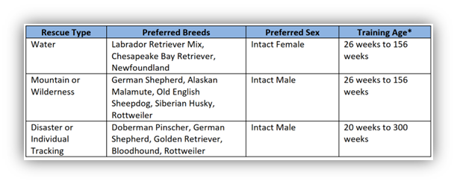

Ther filters are set with specifications provided by the client.

Deleting a record.

Number of documents deleted determined with available property.



Output:



Updating records with current date/time string

## Contact

Your name: Jason Kremhelmer CS-340 August 16, 2024